**SUPPLY CHAIN NETWORK**

**Network between Supplier, Manufacturer, Distribution centre & retailer**

**AIM:**

**-**  reduce system wide cost

- Service Level requirement is satisfied

INFORMATION – binds Procurement, Production & Distribution

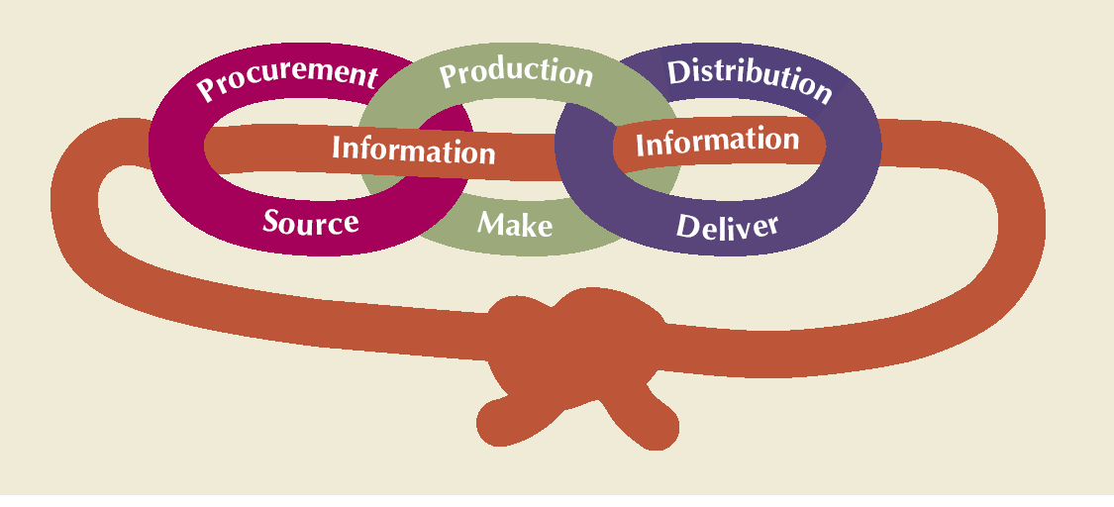

* E.g. Inventory more than required – increase inventory carrying charges and Reduces PROFIT
* Pharmaceutical company – supply chain carries more than 100 days and hence SCM is important

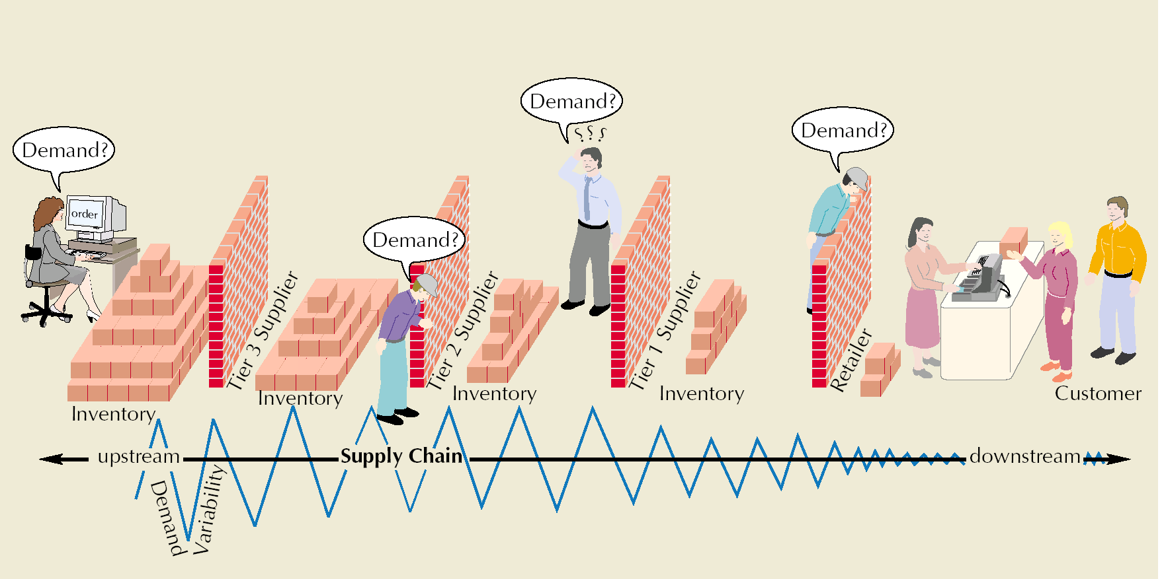**BULLWIP EFFECT: Small** effect on down stream creates a huge impact on upstream

**Methods To Cope up with BULLWIP EFFECT:**

* **Reduces Uncertainty -** by having centralized information
* **VENDOR MANAGED INVENTORY VMI** 🡪 VMI the manufacturer does not rely on the orders placed by a retailer, thus avoiding the bullwhip effect entirely.
* Based on Revenue sharing mechanisum
* Dedicated space given to retailer

|  |  |
| --- | --- |
| **Functional Items** | **Innovative items** |
| Based on PUSH mechanism | **PULL** |
| Demand studied; Forecasted & high demand products are produced in bulk | Pulling the requirement & than produced |
| **Low Profit margin** | **High Profit margin** |
| Requires functional/efficient supply chains | Requires responsive supply chains |
| E,g, Grocery items , FMCG | Fashion items, technology product |
|  |  |

Demand Uncertainty

Certain

Demand

Uncertain

Demand

Efficient

Supply Chain

Responsiveness

Spectrum

Responsive

Supply Chain

Zone of

Strategic Fit

**No idea about this ???????????????**

**Difference between Physically efficient & market responsive Supply chain**

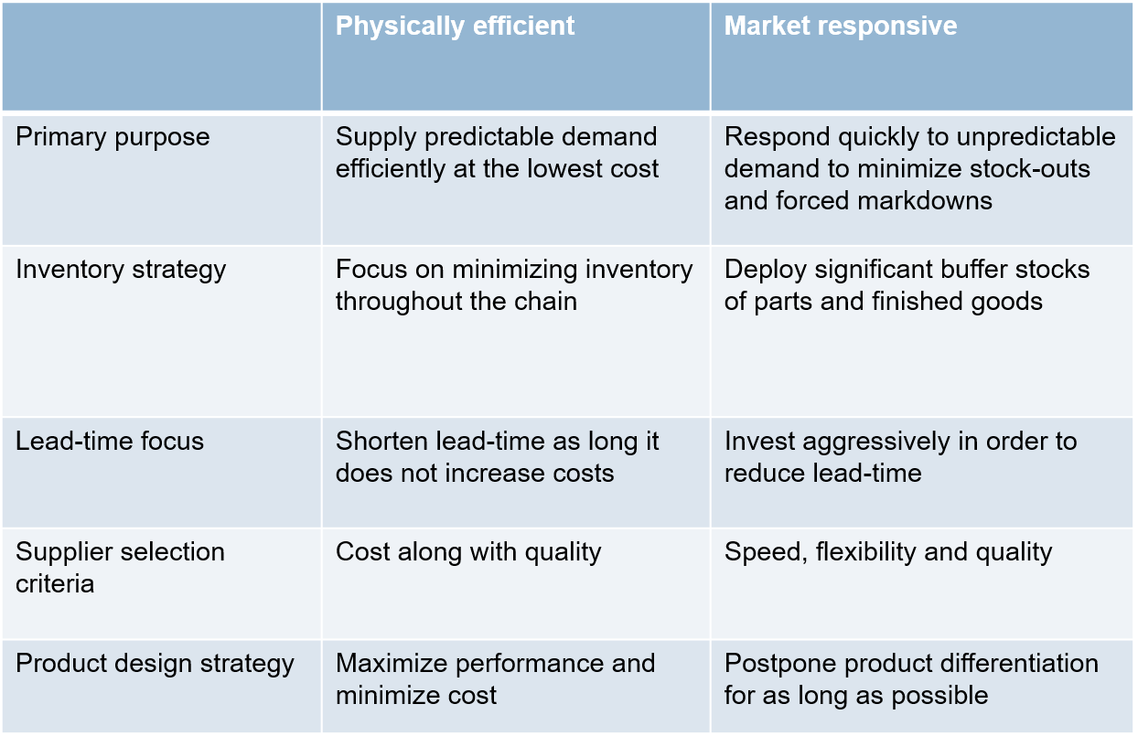

**Ways to cope up high demand uncertainty:**

1. **Build-to-Order**
2. **Risk Pooling**

|  |  |
| --- | --- |
| **Build-to-Order** | **Risk Pooling** |
| Configuration is determined when the order is placed. | Keeping larger inventories at distribution centre |
| **Here** POSTPONMENT & DELAYED DIFFERNTIATION is used | Suitable for product with long distribution cycle |
| **e.g. Dell , Benetton, Asian paint** | **e.g. Vehicle** |
|  |  |

**DELAYED DIFFERENTIATION POSTPONEMENT:** based on component commonality

-- Make to order

-- Here Product is designed in a modular way

e.g. Paint industry, Subway

**COMPONENT PROCUREMENT:**

Components are kept ready & product prepared based on the demand.

Pull based system

e.g. DELL LAPTOPS

** Later Dell moved **from Innovative to functional Product**. It **adopted Push based mechanism instead of delayed differentiation-based mechanism**

**e.g. AIRCRAFT industry** – Make to order as inventory cost is high

|  |  |
| --- | --- |
| **PULL SC** | **PUSH SC** |
| Product & distribution based on long term forecast | Based on true customer demand |
| Reaction time longer to changing market place | **Reacts** to changing market place easily as these firm does not hold any inventory |
| E.g. Grocery item, FMCG | Fashion items, technology product |
|  |  |
|  |  |

**PUSH-PULL Strategy:**

Some stages of supply chain have PUSH systems (Intial basically)

And some stages are based on PULL system

Interface between the two is called Push-Pull boundary

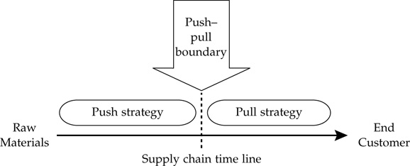

1. **DEMAND UNCERTAINTY**

When the demand is highly uncertain – pull mechanism is used

Demand less uncertain – PUSH mechanism is used

1. **ECONOMIES OF SCALE**

When bulk production does not have any impact on cost – PULL Mechanism used

Supply chain to be maned on the basis on long term demand & aggregation cost is high – PUSH Mechanism used

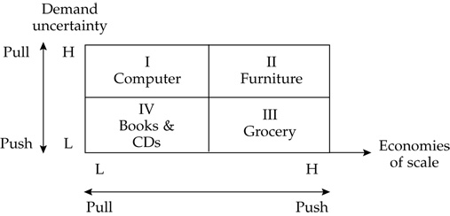

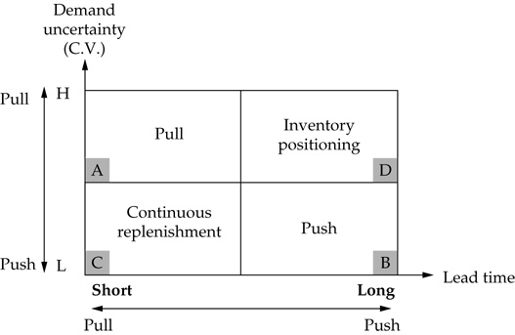

Procurement – art of buying something

**PROCUREMENT STRATEGY: Strategy must be such that there is a continuous supply of material without increasing risk**

Depends on –

1. type of product the firm is purchasing
2. the level of risk & uncertainty

**Sourcing supply strategy by Kraljic-** it depends on two things

1. Profit Impact
2. Supply Risk

PROFIT IMPACT – depends on

* volume purchased
* Percentage of total purchased cost
* Impact on product quality
* Business growth

SUPPLY RISK – depends on

* Availability or resources
* Number of supplier
* Competitive demand
* Number of supplier
* Storage risk
* Substitution opportunity

**Kraljic Supply chain metrics-**

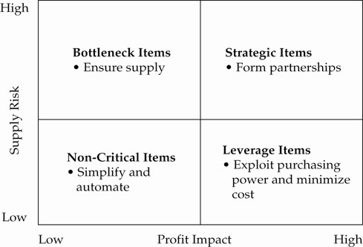

Each Product have a different procurement strategy

|  |  |
| --- | --- |
| **Components – Bottleneck components**  **Risk – High & Profit Low**  Supplier are in better position  Strategy – Entering **in long term bonds with the supplier or carrying stock** | **Strategic item**  **Risk High & Profit** – High  e.g. **car engine** & transmission system  Items having high impact on customer experience & price  Mostly **single supplier**  **Strategy –** have long term partnership with supplier.  **Focus of top management.**  **Purchase may require use of different analytical skills, supply contract, Risk mitigation strategy can be set up** |
| **Components called Non critical items**  **Risk -less & Profit – less**  **Strategy -**  Authorize employees can order directly without any formal procedure or spot purchasing can be done | **Leverage Items**  **Have many supplier. Here small % cost saving will have large impact on bottom lines**  **Risk – low & Profit impact high**  **Strategy** – forcing competion between the supplier |

**SOURCING STRATEGY:**

Till now all the analysis was based on Finished products.

For Sourcing strategy: Fisher’s Framework + Kraljic’s framework is used

Criteria has:

* Component Forecast accuracy
* Component Supply risk
* Component Financial Impact
* Component Clock speed

Component forecast accuracy not similar to finished product accuracy

e.g. car seats used by multiple companies. So according to RISK POOLING high number of products must be required.

|  |  |  |
| --- | --- | --- |
|  |  |  |
| Forecast accuracy | High | Low |
| Supply Risk | Low | High |
| Financial Impact | High | High |
| Clock Speed | Slow | Fast |
|  | Cost based sourcing strategy is appropriate.  Total landed cost must be minimized.  e.g. sourcing from low cost companies | Portfolio approach applied  Combination of long term contract ( short lead time)+ Option contract(Flexibility) + Spot market (multiple supply sources |

Possible decision:

* Dual sourcing
* Long term contract
* Increase flexibility
* Minimize lead time
* Minimize total landed cost
* Option contract
* Portfolio approach
* Strategic partnering

**Aligning Supply Chain Strategies with Product Uncertainties**

